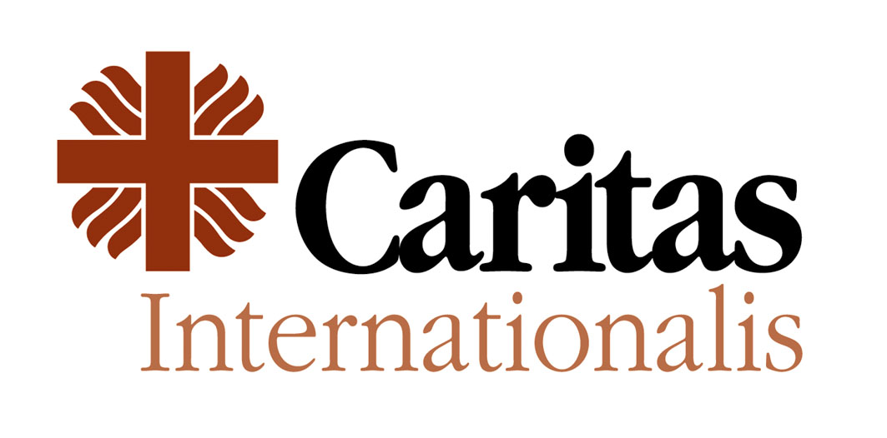

Oral Statement

2017 Global Platform for Disaster Risk Reduction
Cancun, Mexico, 22 – 26 May 2017
Caritas Internationalis congratulates UNISDR for the organisation of the event and appreciates the hospitality and warm welcome by the Government of Mexico and UNISDR.
Responding to disasters and providing humanitarian assistance to those most in need has always been a key priority for the 165 member organizations of the Caritas Confederation.
Our member organizations worldwide are facing huge challenges in responding to the increasing impacts of complex natural and human-made hazards, including the unsettling numbers of refugees and people impacted by conflict, the increasing impacts of climate change, environmental degradation and unregulated urbanization. Consequences on local communities, especially on the most vulnerable and the poorest, are dramatic and carry long-term effects as people work to recover from disasters.
Natural disasters cannot be completely avoided, but there are ways to prevent new and reduce existing disaster risks - especially losses in lives - through strengthening countries’ and local communities’ preparedness and resilience capacities. Learning from past experiences alone may not be enough to respond and mitigate the impact of large scale and often deadly hazards. Developing and designing interventions based on worst-case scenarios and “think the unthinkable” can thus effectively contribute to improving communities’ coping capacities and save lives.
Rooted in the Catholic Social Teaching, Caritas Internationalis places respect for human dignity and protection of the most vulnerable at the very heart of its action. In this regard, Caritas believes that a people-centred and a human rights approach are key to the effective implementation of the Sendai Framework and to bring about real changes in peoples‘ life.

People-centred approach: accountability and participation
Effective implementation of the Sendai Framework, and other interrelated global agendas, will depend on strong accountability to the affected people we serve and on the full participation of local communities in the decision-making process. In line with the localisation agenda, local knowledge, culture and expertise should be valued and prioritised in the design, implementation and monitoring of DRR strategies.
Human Rights-based approach to DRR strategies

As emphasised in the guiding principles of the Sendai Framework international human rights law can play a fundamental role in preventing and reducing disaster risks and should be systematically included in DRR strategies. States have the primary responsibility to protect and provide assistance in an emergency setting, but they have also the primary responsibility to prevent and reduce disaster risks, provided adequate resources are available. Measures adopted toward the full enjoyment of human rights, such as housing and a healthy environment, lead to more effective disaster risk reduction. A human rights-based approach can also ensure the protection of vulnerable groups, including children, women, elderly, people with disabilities, migrants and forced displaced people exposed to the impact of natural or human-made hazards, including violence and conflicts. If grounded in human rights law, inclusive and participatory DRR strategies can effectively strengthen the resilience capacities of people by preventing potential abuses and discrimination in an emergency context, or even environmental degradation.

Thank you

Caritas Internationalis is a global network of 165 humanitarian and development organizations with a moral mandate to respond to humanitarian needs without distinction as to origin, nationality, creed or sex. Caritas plays a pivotal role in humanitarian emergencies and social development. As part of the Catholic Church, Caritas, which is present in nearly 200 countries around the world, has dynamically adopted people-centred initiatives to bring about change in the lives of affected and at risk communities.
Policy coherence between the Sendai Framework, the implementation of the Paris Agreement, the Agenda 2030 including SDGs, the commitments and outcomes of the World Humanitarian Summit, the New Urban Agenda and the New York Declaration shall be ensured.
“Protection of persons and their assets while promoting and protecting all human rights, including the right to development” cf. Sendai Framework for Disaster Risk Reduction.

